Chapter
Location Decisions

Discussion Questions
1. FedEx’s key location concept is the central hub concept, with Memphis selected for several reasons, including its being in the middle of the country and having very few hours of bad weather closures.
2. The major reason for U.S. firms to locate overseas is often lower labor costs, but as this chapter, Chapter 2, and
Supplement 11 suggest, there are a number of considerations.
3. The major reason foreign firms build in the U.S. is to satisfy the demand for foreign goods in the United States while reducing transportation cost and foreign exchange risk; in addition, U.S. locations allow foreign firms to circumvent quotas and/or tariffs.
4. Clustering is the tendency of firms to locate near competitors.
5. Different weights can be given to different factors. Personal preferences are included.
6. The qualitative approach usually considers many more factors, but its results are less exact.
7. Clustering examples in the service sector include fast-food restaurants, shoe and jewelry stores in a shopping mall, and theme parks.
8. Factors to consider when choosing a country:
- Exchange rates
- Government stability (political risk)
- Communications systems within the country and to the home office
- Wage rates
- Productivity
- Transportation costs
- Language
- Tariffs
- Taxes
- Attitude towards foreign investors/incentives
- Legal system
- Ethical standards
- Cultural issues
- Supplies availability
- Market locations
9. Factors to consider in a region/community decision:
- Corporate desires
- Attractiveness of region
- Labor issue
- Utilities
- Environmental regulations
- Incentives
- Proximity to raw materials/customers
- Land/construction costs
10. Franchise operations may add new units per year; Exxon, McDonald’s, and Wal-Mart add hundreds of units per year, almost
a daily location decision. For such organizations, the location decision becomes more structured, more routine. Perhaps by repeating this process they discover what makes their strategic locations decisions successful.
11. Factors affecting location decisions: nearness to resources, suppliers, and customers; labor productivity; foreign exchange; political risk, unions; employment; zoning; pollution; taxes; and clustering.
12. The center-of-gravity method assumes that cost is directly proportional to both distance and volume shipped. For service facilities, revenue is assumed to be directly proportional to proximity to markets.
13. Locational break-even analysis three steps:
- Step 1: Determine fixed and variable cost for each
location.
- Step 2: Plot the costs for each location, with costs on the vertical axis of the graph and annual volume on the horizontal axis.
- Step 3: Select the location that has the lowest total cost for the expected production volume.
14. The issue of weight or volume gain and weight or volume loss during processing is important, and supports the manufacturing side of the saying (weight loss during mining and refining, for example, suggests shipping after processing). But JIT may be more easily accomplished when suppliers are clustered near the customer. And some services (such as Internet sales) can take place at tremendous distances without sacrificing close contact.
15. Besides low wage rates, productivity should be considered also. Employees with poor training, poor education, or poor work habits are not a good buy. Moreover, employees who cannot or will not reach their place of work are not much good to the organization.
16. Service location techniques: regression models to determine importance of various factors, factor rating method, traffic counts, demographic analysis of drawing area, purchasing power analysis of area, center-of-gravity method, and geographic information system.
17. The distributor is more concerned with transportation and storage costs, and the supermarket more concerned with proximity to markets. The distributor will focus more on roads, overall population density (store density), while the supermarket will focus more on neighborhood affluence, traffic patterns, etc. The distributor will be concerned with speedy and reliable delivery, the supermarket with easy access. Both will have concerns over attitudes and zoning. Both will need access to similar labor forces; both will need similar measures of workforce education, etc. Many other comparisons can be drawn.
18. This is a service location problem, and should focus on revenues, not costs. Customer traffic, customer income, customer density, are obvious beginning points. Parking/access, security/ lighting, appearance/image, rent, etc. (see Table 8.6) are other important variables.

Ethical Dilemma
Location is a major issue in the U.S. today. Almost every community is seeking new jobs, especially from foreign firms like Mercedes. As Mercedes was definitely coming to the U.S. anyway, the bidding wars are nonproductive from a central economy perspective. There are many implications to the local citizenry, especially because they pay the bills if the financial successes predicted are not accurate. Votes are usually not taken as these decisions are made by the political leaders of the community. Objective economic analysis on the incentives versus benefits might limit the giveaways.
As the United Airlines discussion suggests, there are many downsides to the spread of incentives being offered by almost every city, state, and country. Orlando and Louisville are likely counting their blessings that they lost the bidding war for the United repair base. For every happy ending (such as Vance, Alabama, claims with its Mercedes plant), there is a story like the one in this Ethical Dilemma. The Internet should yield a rich crop of similar situations.

Active Model Exercise

Active Model 8.1 Center of Gravity
1. What is the total weighted distance from the current old and inadequate warehouse in Pittsburgh?

318,692
2. If they relocate their warehouse to the center of gravity, by how much will this reduce the total weighted shipping distance?
By 18,663—from 318,692 to 300,029.
3. Observe the graph. If the number of shipments from New York doubles, how does this affect the center of gravity?

The center of gravity moves north and east.
4. The center of gravity does not necessarily find the site with the minimum total weighted distance. Use the scrollbars to move the trial location and see if you can improve (lower) the distance.
64, 97 with a total weighted distance of 299, 234 (using Solver).
5. If you have Solver set up in Excel, from Excel’s main menu, use Tools, Solver, Solve in order to see the best answer to the previous question.
64, 97 with a total weighted distance of 299, 234.

End-of-Chapter Problems
8.1 Where: Six laborers each making $3 per day can produce 40 units.
Ten laborers each making $2.00 per day can produce 45 units.
Two laborers each making $60 per day can make 100 units.
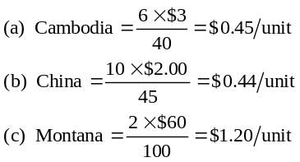
China is most economical, assuming that transportation costs are not included.
8.2 Cambodia $0.45 + $1.50 = $1.95
China $0.44 + $1.00 = $1.44
Montana $1.20 + $0.25 = $1.45
China is most favorable, but Montana is almost tied.
8.3 Thailand: 2,000 baht/200 = 10 baht/unit,
if $1 = 10 baht ⇒$1/unit
India: 2,000 rupees/200 = 10 rupees/unit,
if $1 = 8 rupees ⇒ $1.25/unit

Sacramento (U.S.A.): $200/200 = $1/unit
Select either Thai or U.S. company.
8.4 If India had a tariff of 30%, then making the items in India is $0.05 less than importing them from anywhere.
8.5 (a) Baptist Church is best.
 | Site
 | Maitland |  |  | Baptist Church |  |  | Northside Mall
Factor | (weight × score) |  |  | (weight × score) |  |  | (weight × score)
Space | 18 |  |  | 21 |  |  | 24
Costs | 10 |  |  | 20 |  |  | 7.5
Traffic density | 10 |  |  | 16 |  |  | 12
Neighborhood  income | 7.5 |  |  | 10.5 |  |  | 6
Zoning laws | 8 |  |  | 2 |  |  | 9
Totals |  | 53.5 |  |  | 69.5 |  |  | 58.5
(b) The totals are now Maitland, 52.5; Baptist Church, 70.5; and Northside Mall, 56.5. Baptist Church’s location is even more preferred.
8.6 (a) Atlanta = 0.4(80) + 0.3(20) + 0.2(40) + 0.1(70) = 53
Charlotte = 0.4(60) + 0.3(50) + 0.2(90) + 0.1(30) = 60
Charlotte is better.
(b) A change to 75 (from 60) in Charlotte’s incentive package does not change the answer to part (a) because Charlotte was
already the better site. The new Charlotte score is now 66 overall, while Atlanta stays at 53.

8.7
Factor | Philadelphia  (weight × score) |  |  | New York  (weight × score)
Customer
convenience | 17.5 |  |  | 20
Bank accessibility | 8.0 |  |  | 18
Computer support | 17.0 |  |  | 15
Rental costs | 13.5 |  |  | 8.25
Labor costs | 8.0 |  |  | 5.0
Taxes | 9.0 |  |  | 5.0
Totals |  | 73.0 |  |  | 71.25
ILA should locate in Philadelphia.
8.8 (a)
Location
Factor | Present Location  Wgt |  |  |  |  |  | Newbury  Wgt |  |  |  |  | Hyde Park  Wgt
1 | 40 | 0.30 | 12 |  |  |  | 60 | 0.30 | 18.00 |  |  | 50 |  | 0.30 | 15.0
2 | 20 | 0.15 | 3 |  |  |  | 20 | 0.15 | 3.00 |  |  | 80 |  | 0.15 | 12.0
3 | 30 | 0.20 | 6 |  |  |  | 60 | 0.20 | 12.00 |  |  | 50 |  | 0.20 | 10.0
4 | 80 | 0.35 | 28 |  |  |  | 50 | 0.35 | 17.50 |  |  | 50 |  | 0.35 | 17.5
 | Total Points |  |  |  | 49 |  | Total Points |  |  | 50.50 |  |  | Total Points |  |  | 54.5

It appears that Hyde Park represents the best alternative.
(b) If Present Location’s public transportation score increases from 30 to 40, the total score increases by 10 points × 0.20 weight = 2.0 points. So the new score is 51 points for Present Location, which is still not as good as Hyde Park’s score.
8.9 (a) The weighted averages are:
Akron 81.5
Biloxi 80.0
Carthage 87.5
Denver 76.0
 |  |  |  |  | Akron |  |  |  |  | Biloxi |  |  |  |  | Carthage |  |  |  |  | Denver
Factor | Weight |  |  | Score |  | Weight ×  Score |  |  | Score |  | Weight ×  Score |  |  | Score |  | Weight ×  Score |  |  | Score |  | Weight ×  Score
Labor | 0.15 |  |  | 90 |  | 13.5 |  |  | 80 |  | 12.0 |  |  | 90 |  | 13.5 |  |  | 80 |  | 12.0
Availability
Tech. School | 0.10 |  |  | 95 |  | 9.5 |  |  | 75 |  | 7.5 |  |  | 65 |  | 6.5 |  |  | 85 |  | 8.5
Quality
Operating Cost | 0.30 |  |  | 80 |  | 24.0 |  |  | 85 |  | 25.5 |  |  | 95 |  | 28.5 |  |  | 85 |  | 25.5
Land &
Construction | 0.15 |  |  | 60 |  | 9.0 |  |  | 80 |  | 12.0 |  |  | 90 |  | 13.5 |  |  | 70 |  | 10.5
Ind. Incentives | 0.20 |  |  | 90 |  | 18.0 |  |  | 75 |  | 15.0 |  |  | 85 |  | 17.0 |  |  | 60 |  | 12.0
Labor Cost | 0.10 |  |  | 75 |  | 7.5 |  |  | 80 |  | 8.0 |  |  | 85 |  | 8.5 |  |  | 75 |  | 7.5
 |  | 1.00 |  |  |  |  | 81.5 |  |  |  |  | 80.0 |  |  |  |  | 87.5 |  |  |  |  | 76.0

(b) Carthage is preferred (87.5 points) in the initial scenario.
 |  |  |  |  | Akron |  |  |  |  | Biloxi |  |  |  |  | Carthage |  |  |  |  | Denver
Factor | Weight |  |  | Score |  | Weight ×  Score |  |  | Score |  | Weight ×  Score |  |  | Score |  | Weight ×  Score |  |  | Score |  | Weight ×  Score
Labor | 0.15 |  |  | 90 |  | 13.5 |  |  | 80 |  | 12.0 |  |  | 90 |  | 13.5 |  |  | 80 |  | 12.0
Availability
Tech. School | 0.10 |  |  | 95 |  | 9.5 |  |  | 75 |  | 7.5 |  |  | 65 |  | 6.5 |  |  | 85 |  | 8.5
Quality
Operating Cost | 0.10 |  |  | 80 |  | 8.0 |  |  | 85 |  | 8.5 |  |  | 95 |  | 9.5 |  |  | 85 |  | 8.5
Land &
Construction | 0.15 |  |  | 60 |  | 9.0 |  |  | 80 |  | 12.0 |  |  | 90 |  | 13.5 |  |  | 70 |  | 10.5
Ind. Incentives | 0.20 |  |  | 90 |  | 18.0 |  |  | 75 |  | 15.0 |  |  | 85 |  | 17.0 |  |  | 60 |  | 12.0
Labor Cost | 0.30 |  |  | 75 |  | 22.5 |  |  | 80 |  | 24.0 |  |  | 85 |  | 25.5 |  |  | 75 |  | 22.5
 |  | 1.00 |  |  |  |  | 80.5 |  |  |  |  | 79.0 |  |  |  |  | 85.5 |  |  |  |  | 74.0
(c) In the second scenario, all four scores fall to smaller values, Carthage more than the others, but it is still
firmly in first place. All scores are smaller because all sites had operating cost scores better than labor cost scores. When labor cost takes on the higher weight, the lower scores have more influence on the total.
The new scores are:
Akron 80.5
Biloxi 79.0
Carthage 85.5
Denver 74.0

8.10 (a)
Location A
Factor | Weight | Rating | Weighted Score
1 | 5 | 100 | 500
2 | 3 | 80 | 240
3 | 4 | 30 | 120
4 | 2 | 10 | 20
5 | 2 | 90 | 180
6 | 3 | 50 | 150
 | Total weighted score: |  |  | 1210

Location B
Factor | Weight | Rating | Weighted Score
1 | 5 | 80 | 400
2 | 3 | 70 | 210
3 | 4 | 60 | 240
4 | 2 | 80 | 160
5 | 2 | 60 | 120
6 | 3 | 60 | 180
 | Total weighted score: |  |  | 1310

Location C
Factor | Weight | Rating | Weighted Score
1 | 5 | 80 | 400
2 | 3 | 100 | 300
3 | 4 | 70 | 280
4 | 2 | 60 | 120
5 | 2 | 80 | 160
6 | 3 | 90 | 270
 | Total weighted score: |  |  | 1530
Based on the total weighted scores, Location C should be recommended.
Note that raw weights were used in computing these weighted scores (we just multiplied “weight” times “rating”). Relative weights could have been used instead by taking each factor weight and dividing by the sum of the weights (i.e., 19). Then the weight for factor 1 would have been 5/19 = 0.26. Location C would still have been selected.
(b) Location B’s “Proximity to Port Facilities” score increases from
80 to 90: The total score increases by 10 × (5 weight) = 50, to 1,360 points.
(c) To change its rank to first place, Location B needs to increase to at least 1,530 points from 1,310. Even if the score is 100, the total only increases to 1,410, so B will stay as the second choice. To end up in third place, if the rating drops below 60, the total weighted score drops below 1,210, which is Location A’s total score.
8.11 (a)
Factor | Weight | Taiwan |  |  | Thailand |  |  | Singapore
Technology | 0.2 | .8 |  |  | 1.0 |  |  | .2
Level of education | 0.1 | .4 |  |  | .1 |  |  | .5
Political/legal | 0.4 | .4 |  |  | 1.2 |  |  | 1.2
Social | 0.1 | .4 |  |  | .2 |  |  | .3
Economic | 0.2 | .6 |  |  | .6 |  |  | .4
Weighted average |  |  | 2.6 |  |  | 3.1 |  |  | 2.6
Thailand rates highest (3.1).
(b) Now Thailand’s overall score drops to 2.7, just ahead (but not by much) of Taiwan and Singapore.
(c) Now Thailand’s score drops to 2.3, leaving the other two countries in a tie for first place.
8.12 (a) Given the factors and weightings presented, the following table suggests that Great Britain be selected:

 |  |  |  |  | Great
 | Factor | Holland |  |  | Britain |  |  | Italy |  |  | Belgium |  |  | Greece
1 | Stability of | 5 |  |  | 5 |  |  | 3 |  |  | 5 |  |  | 4
 | government
2 | Degree to | 4 |  |  | 5 |  |  | 3 |  |  | 4 |  |  | 3
 | which the
 | population can
 | converse in
 | English
3 | Stability of | 5 |  |  | 4 |  |  | 3 |  |  | 4 |  |  | 3
 | the monetary
 | system
4 | Communications | 4 |  |  | 5 |  |  | 3 |  |  | 4 |  |  | 3
 | infrastructure
5 | Transportation | 5 |  |  | 5 |  |  | 3 |  |  | 5 |  |  | 3
 | infrastructure
6 | Availability of | 3 |  |  | 4 |  |  | 5 |  |  | 3 |  |  | 5
 | historic/
 | cultural sites
7 | Import | 4 |  |  | 4 |  |  | 3 |  |  | 4 |  |  | 4
 | restrictions
8 | Availability of | 4 |  |  | 4 |  |  | 3 |  |  | 4 |  |  | 3
 | suitable
 | quarters
 |  | 34 |  |  | 36 |  |  | 26 |  |  | 33 |  |  | 28

(b) If English is not an issue, as illustrated in the following table, Great Britain, Holland, and Belgium should all be considered further:
 |  |  |  |  | Great
 | Factor | Holland |  |  | Britain |  |  | Italy |  |  | Belgium |  |  | Greece
1 | Stability of | 5 |  |  | 5 |  |  | 3 |  |  | 5 |  |  | 4
 | government
3 | Stability of the | 5 |  |  | 4 |  |  | 3 |  |  | 4 |  |  | 3
 | monetary
 | system
4 | Communications | 4 |  |  | 5 |  |  | 3 |  |  | 4 |  |  | 3
 | infrastructure
5 | Transportation | 5 |  |  | 5 |  |  | 3 |  |  | 5 |  |  | 3
 | infrastructure
6 | Availability of | 3 |  |  | 4 |  |  | 5 |  |  | 3 |  |  | 5
 | historic/
 | cultural sites
7 | Import | 4 |  |  | 4 |  |  | 3 |  |  | 4 |  |  | 4
 | restrictions
8 | Availability of | 4 |  |  | 4 |  |  | 3 |  |  | 4 |  |  | 3
 | suitable
 | quarters
 |  | 30 |  |  | 31 |  |  | 23 |  |  | 29 |  |  | 25

8.13 (a)
Site | Total Weighted Score
A | 174
B | 185
C | 187
D | 165

Site C has the highest total weighted score so should be selected. (As a practical matter, when scores are as close as those for Sites B and C, further analysis is warranted.)
(b) Site D’s total score is now raised from 165 to 175. Although D ranks slightly higher than A, the results do not change.
(c) Site A’s total score increases by 12 points, to 186. This is now close to a three-way tie between sites A, B and C. Other factors need to be introduced.

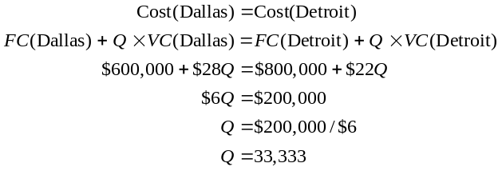8.14 (a)
Germany: | 0.05(5) + 0.05(4) + 0.2(5) + 0.2(5) + 0.2(1) + 0.1(4) + 0.1(1) + 0.1(2) = 3.35
Italy: | 0.05(5) + 0.05(2) + 0.2(5) + 0.2(2) + 0.2(4) + 0.1(2) + 0.1(4) + 0.1(3) = 3.45
Spain: | 0.05(5) + 0.05(1) + 0.2(5) + 0.2(3) + 0.2(1) + 0.1(1) + 0.1(4) + 0.1(1) = 2.7
Greece: | 0.05(2) + 0.05(1) + 0.2(2) + 0.2(5) + 0.2(3) + 0.1(1) + 0.1(3) + 0.1(5) = 3.05

Italy is highest.
(b) Spain’s cost would drop, but the result would not change with a 4, since Spain is already lowest. No score will change Spain’s last place.
8.15 (a) Chicago = 16 + 6 + 7 + 4 = 33

Milwaukee = 10 + 13.5 + 6 + 3 = 32.5
Madison = 12 + 12 + 4 + 2.5 = 30.5
Detroit = 14 + 6 + 7 + 4.5 = 31.5
All four are quite close, with Chicago and Milwaukee almost tied. Chicago has the largest rating, with a 33.
(b) With a cutoff of 5, Chicago is unacceptable because it scores only 4 on the second factor. Only Milwaukee has scores of 5 or higher on all factors. Detroit and Madison are also eliminated, as each has one rating of a 4.
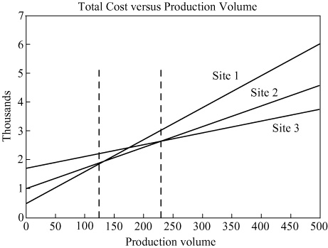
8.16 (a) The following figure indicates the volume range for which each site is optimal.
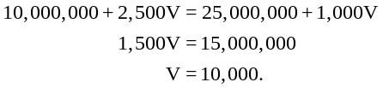Site 1 is optimal for production less than or equal to 125 units.
Site 2 is optimal for production between 125 and
233 units.
Site 3 is optimal for production above 233 units.
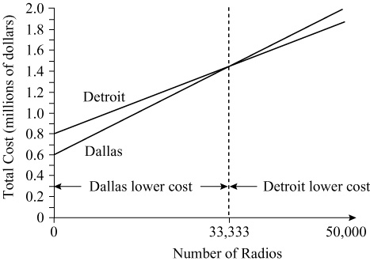
(b) For 200 units, site 2 is optimal.
8.17 (a) See the figure below:

(b) Q drops to 23,333, from 33,333.
since $660,000 + 28Q = $800,000 + 22Q
so, 6Q = 140,000
or Q = 23,333
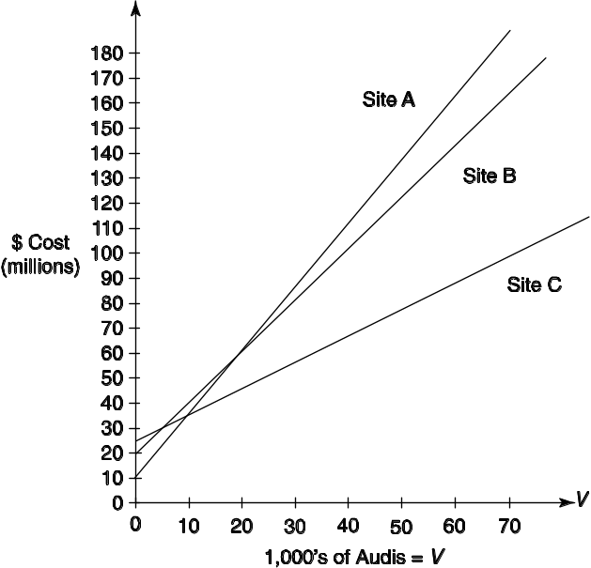
8.18 (a)

For all volumes above 10,000, site C has the lowest cost.
(b) Site A is optimal for volumes from 0 to 10,000 Audis.
(c) Site B is never optimal because its cost line always exceeds that of A or C for all volume levels.
8.19 (a) Crossover is where ProfitBonham = ProfitMcKinney;
or – 800,000 + 15,000X = – 920,000 + 16,000X
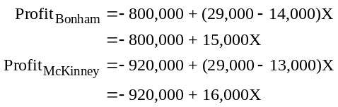Crossover is at 120 units.
(b, c) McKinney is preferable beyond 120 units, Bonham below 120 units.
(d) Bonham has break-even at about 53 units; McKinney about 58, so both are beyond break-even at the
crossover.
8.20 (a)
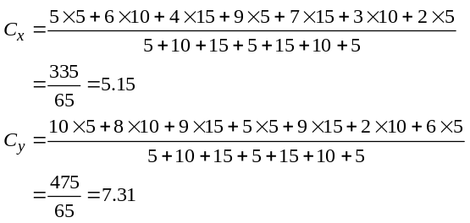
The proposed new hub should be near (5.15, 7.31).
(b) When the shipment loads from City A triple, from 5 to 15, the new coordinates are (5.13, 7.67).

8.21
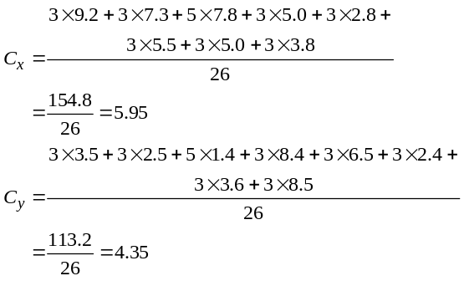
The distance-minimizing location is at (5.95, 4.35). This minimizes distance traveled, but is “straight line,” which does not reflect realities of highway routes. It does not consider rivers, bridges, and other geographical impediments. Consider placing the office as near the center of gravity as possible and still be on or near a major highway. Students who overlay this onto a map of Louisiana should recognize that Baton Rouge would be an ideal location.
8.22
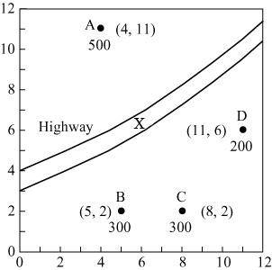
A (North Park) | (4, 11) | 500
B (Jefferson) | (5, 2) | 300
C (Lincoln) | (8, 2) | 300
D (Washington) | (11, 6) | 200
 |  | 1300

(a)
X = New middle school to serve 4 elementary schools.
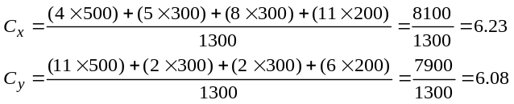(b) Other considerations:
- Cannot locate on the highway, obviously
- Safety—pedestrian bridge
- Space for school and grounds
- Traffic
- Availability of land and its price

8.23 (a)
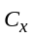 = x coordinate of center of gravity
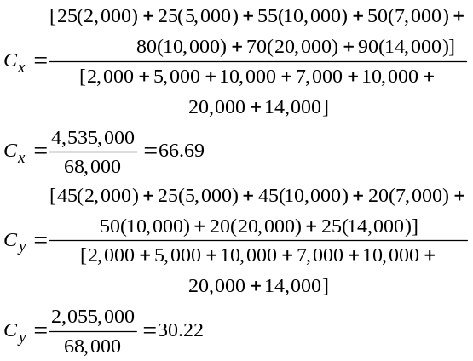
The center of gravity is (66.69, 30.22).
(b) When Census tracks 103 and 105 increase by 20% each, from 10,000 to 12,000 population, the new coordinates become (66.74, 31.18). Coordinate denominators increase (by 2,000
+ 2,000) to 72,000. The x-coordinate numerator increases (by 55(2,000) + 80(2,000)) to 4,805,000. The y-coordinate numerator increases (by 45(2,000) + 50(2,000)) to 2,245,000.
8.24 (a) Calculate the overall site scores for each site:
Site | Overall Score
A | 20(5) + 16(2) + 16(3) + … + 10(5) = 348
B | 20(4) + 16(3) + 16(4) + … + 10(4) = 370
C | 20(4) + 16(4) + 16(3) + … + 10(3) = 374
D | 20(5) + 16(1) + 16(2) + … + 10(3) = 330
Site C is best
(b) Replace 10 by w7 in the overall score calculations above. Get overall site scores as a function of w7 thereby:
Site | Overall Score
A | 20(5) + 16(2) + 16(3) + … + 5w7 = 298 + 5w7
B | 20(4) + 16(3) + 16(4) + … + 4w7 = 330 + 4w7
C | 20(4) + 16(4) + 16(3) + … + 3w7 = 344 + 3w7
D | 20(5) + 16(1) + 16(2) + … + 3w7 = 300 + 3w7
Now find all values (a) 344 + 3w7 ≥ 298 + 5w7

of w7 such that (b) 344 + 3w7 ≥ 330 + 4w7
(a), (b), & (c) all hold: (c) 344 + 3w7 ≥ 300 + 3w7
Results:
(a) states w7 ≤ 23 (b) states w7 ≤ 14
(c) states 344 ≥ 300 (which holds for all values of w7).
For all positive values of w7 such that w7 ≤ 14.

8.25 (a) Weighted scores
British International Airways
Milan | Rome | Genoa | Paris | Lyon | Nice
3,415 | 2,945 | 3,425 | 3,155 | 3,970 | 3,660
Munich | Bonn | Berlin
3,425 | 3,915 | 3,665
So, for part (a) the top three cities become: Lyon is best (3,970), Bonn is second (3,915), and Berlin is third (3,665).
(b) Weighted scores with hangar weights modified:
British International Airways
Milan | Rome | Genoa | Paris | Lyon | Nice
3,215 | 2,825 | 3,345 | 2,795 | 3,730 | 3,460
Munich | Bonn | Berlin
3,065 | 3,555 | 3,585
So, for part (b) the top three cities become: Lyon is best (3,730), Berlin is second (3,585), and Bonn is third (3,555).
(c) German cities reweighed on financial incentives:
British International Airways
 | Munich | Bonn | Berlin
Weighted Score | 3,320 | 3,810 | 3,840
Yes, increasing the financial incentive factors to 10 for the three German cities of Munich, Bonn, and Berlin changes the top three cities to Berlin (3,840), Bonn (3,810), and Lyon (3,730).

Additional Homework Problems
Here are solutions to additional homework problems that appear on our Web site, www.pearsonglobaleditions.com/myomlab.
8.26 To aid in this analysis, we assign a rating to each “grade”.
Grade | Rating
A | 4
B | 3
C | 2
D | 1
and to each “factor”:
Factor | Rating
Rent | 1.00
Walk-in | 0.90
Distance | 0.72
and compute overall ratings for each location:
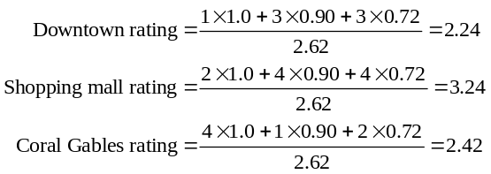
If you do not divide by the sum of the weights, the respective ratings are 5.86, 8.48, and 6.34. The shopping mall receives the highest rating using this site selection approach.

8.27
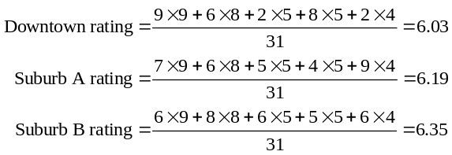
Suburb B has the highest rating, but weights should be examined using sensitivity analysis, as the final ratings are all close.

8.28
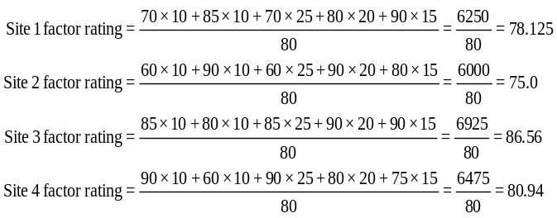
Site 3 has the highest rating factor, 86.56, and should be selected.

8.29
(a)

1,000,000 + 73X = 800,000 + 112X
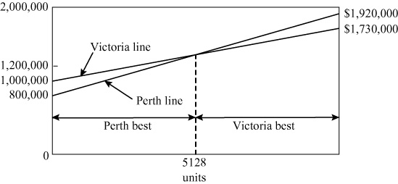

200,000 = 39X or X = 5,128
(b) For 5,000 units, Perth is the better option.

8.30
(a)

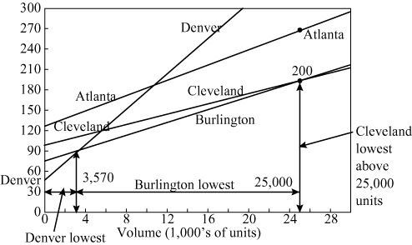
The total cost equations are:
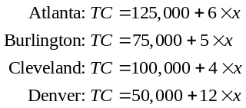
(b) Denver is preferable over the range from 0–3,570 units. Burlington is lowest cost at any volume exceeding 3,570, but less than 25,000 units. Atlanta is never lowest in cost. Cleveland becomes the best site only when volume exceeds 25,000 units per year.

(c) At a volume of 5,000 units, Burlington is the least-
cost site.

8.31
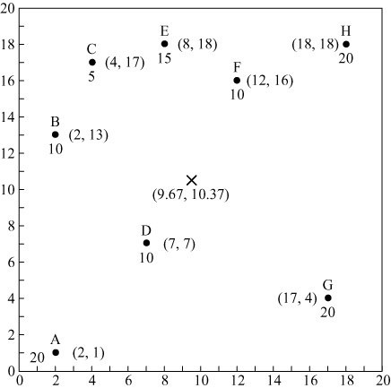

City | Map Coordinates | Shipping Load
A | 2,1 | 20
B | 2,13 | 10
C | 4,17 | 5
D | 7,7 | 20
E | 8,18 | 15
F | 12,16 | 10
G | 17,4 | 20
H | 18,18 | 20
 |  | 120

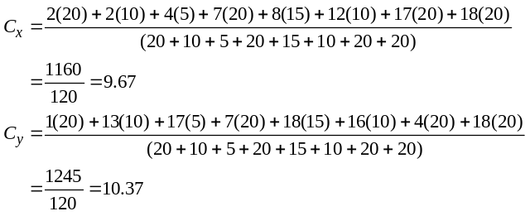
8.32
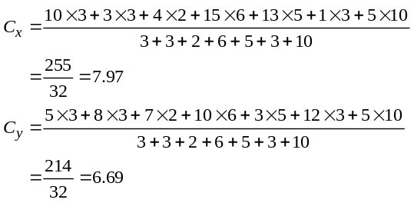
The proposed new facility should be near (7.97, 6.69).
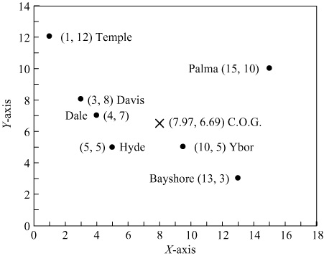
8.33 With equal weights of 1 for each of the 15 factors:
 | Total | Average
Spain | 39 | 2.60
England | 52 | 3.47
Italy | 50 | 3.33
Poland | 41 | 2.73
England is the top choice.
8.34 With weights given, the result became:
Spain 2.55
England 3.55
Italy 3.30
Poland 2.80
England remains the top selection.
Case study
finding a location for electronics component manufacturing in asia
- What advantages and disadvantages does each potential location offer?
Singapore
Advantages: labor relatively cheap, good transport infrastructure and incentives offered to stay.
Disadvantages: increasing labor costs and increasing utility costs.
Hong Kong
Advantages: labor consistently cheap and good transport infrastructure.
Disadvantages: no specific disadvantage has been identified in the case but students should attempt to discuss this further.
Malaysia
Advantages: access to raw materials and natural resources inexpensive labor.
Disadvantages: Concern with frequency of ship visits.

- What other relevant factors that are not mentioned in the case study might play a role in this decision?
The education of the workforce (both current workforce and future generations) as well as political stability will impact the decision.

- Why is transportation infrastructure so important in this decision?
Since ACM is reliant on logistics for raw materials and transporting final products to customers, transportation costs (both current and expected development of the costs) will doubtlessly have a large impact on the decision.

- This is a long-term strategic decision; what factors might change in the next ten to twenty years? How will this influence the decision?
Since the plant will “pay for itself” over a long time horizon, decision relevant costs must be examined not only at their current level but also how this is expected to develop over the horizon. Examples of costs which are likely to change and whose change would make or break the decision would include labor costs, utility costs, raw material costs, transport costs. Also other difficult to forecast developments such as exchange rates and political stability will impact the profitability.

- Which alternative would you recommend, under which circumstances?

Answers will vary but students should discuss how to approach the problem of selecting the appropriate location. For example, if possible, students should explore the use of factor-rating method for this problem.

Video case studies
LOCATING THE NEXT RED LOBSTER RESTAURANT
1. MapInfo has 72 clusters that provide socioeconomic profiling. These profiles (PSYTE) provide interesting reading and data for class discussion. MapInfo would tell you that the applications are virtually limitless. For instance, the BusinessMAP database includes the following datasets to aid financial institution location decisions:
1
- ESRI’s current-year and 5-year-out estimates for population, age, race, and income
- Branch location, asset, and deposit information from RPM Consulting’s Branchinfo
- MarketBank data, with information about deposit and loan potential
- National Credit Union Association data on member assets, loans, etc.
- Segmented lifestyle/life change information
- D & B listings
- Street level maps
Data such as the above helps the location decision by providing current and potential deposit and loan information as well as information about the competition.
Sources: www.esri.com/bmapfinancial, www.esri.com/archnews, and www.esri.com/partners.
2. Many differences can be identified in an assignment or class discussion, but restaurants want disposable income, while retail—depending on the type of retail—wants high traffic, and manufacturing wants a focus on costs, infrastructure, and low taxes.
3. Darden has shied away from urban locations; high location costs do not fit its current model, but Darden has found fertile ground in first- and second-tier suburban and exurban/small (over 90% of the Red Lobsters are in these three density classes). Incidentally, in 2010, Darden announced it will begin to open facilities outside the U.S. and Canada.

WHERE TO PLACE THE HARD ROCK CAFE
2
1. The attached report details the information that Munday collects and analyzes about each site. As such, it provides the answer to the first question.
2. The ratings of the four cities are:
A = 80.5, B = 64.5, C = 71.5, and D = 79.5. So City A is a close first choice over City D. In reality, they are so close that other considerations may be included, or sensitivity analysis on scores or weights performed.
3. Expansion is the lifeblood of any global organization. Good decisions mean a 10- to 20-year cash flow. Bad ones mean a 10-plus year commitment to a money-losing location.
4. Hard Rock considers political risk, crime, currency, and other factors in location decisions abroad. In Russia and Colombia, corruption is so endemic that having a local partner who can understand and handle these issues is a necessity.
Hard Rock Report (cont’d)
4. Attendance
5. Future Bookings
6. Expansion Plans
7. Major Conventions
Attractions
- Entertainment (Including location, seats, attendance)
1. Theaters (Including live performance space)
2. Cinemas (Including IMAX)
3. Theme Parks
4. Zoo/Aquarium
5. Historic Sites
- Sports (Capacity, annual attendance, location, age
of facility, etc.)
1. Soccer
2. Rugby
3. Baseball
4. Minor Leagues
- Retail (Size, tenants, visitors, seasonality)
1. Regional Shopping Centers
2. Discount Shopping Centers
3. Shopping Districts
Transportation
- Airport
1. Age
2. Passengers Annually
3. Airlines (Indicate hub city)
4. Direct Flights
- Rail
- Road
- Sea/River
Restaurants (A selection of restaurants in key areas of the target market)
1. Name
2. Location
3. Type
4. Seats
5. Age
6. Estimated Gross Sales
7. Average check
8. Size of Bar
9. Outside Dining Facilities
Nightclubs (A selection of clubs/casinos etc. in key
areas of the target market)
1. Name
2. Location
3. Type
4. Seats/capacity
5. Age
6. Estimated Gross Sales
7. Average check
8. Size of Bar
9. Music type (e.g., live/disco/combination)
Hard Rock Cafe
Standard Market Report (Offshore)
Executive Summary
Introduction
- Purpose
- Product Type (e.g., franchise or company owned, cafe,
hotel, casino)
- Overview of City/Market (e.g., set context) including
history, macro-economic summary
Demographics (Local, City, Region SMSA, or
equivalent)
- Population (Trend analysis, if possible)
1. Number
2. Age
3. Households
4. Average Household Income
- Economic Indicators (Trend analysis, if possible)
1. Cost of Living Index (compared to national average)
2. Unemployment
3. Size of Workforce
4. Employment by sector
5. Major employers
Visitor Market
- Tourism/Business Visitor (Trend analysis, if possible)
1. Number
2. Origins
3. Length of Stay
4. Average Spend
5. Size of Party
6. Reasons for Visit
7. Frequency of Repeat Visits
8. Seasonality
9. Method of Transportation
- Hotels (Trend analysis, if possible)
1. Hotel Room Inventory
2. Occupancy Rates (Annual and monthly for seasonality)
3. Room Rates
4. Function Room Demand
5. Recent Development
6. Future Development
- Convention Center (Trend analysis, if possible)
1. Size
2. National Ranking
3. Days Booked per annum

Hard Rock Report (cont’d)
Real Estate Market Overview
1. Introduction
2. Retail Rents
3. Recent Developments
4. Future Developments
HRC Comparable Market Analysis
1. Identify comparable existing HRC markets
2. Explain similarities (e.g. regional population, visitors, hotel rooms, seasonality, etc.)
3. Prepare city P&L spreadsheet analysis
Conclusion
1. Estimate of Gross Food & Beverage Revenue for market in General with backup and comparables
2. Estimate of Gross Merchandise Revenue for market in General with backup and comparables
3. Preferred locations
4. Sizzle (How will we make ourselves special in this market?)
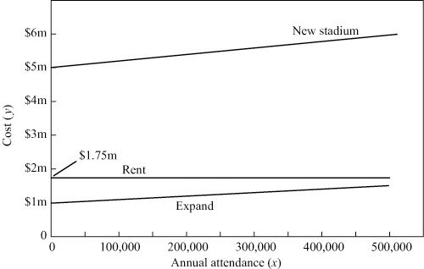

Additional Case Study*
SOUTHWESTERN UNIVERSITY: E
1. The five factors appear reasonable. Many others could be included, such as potential parking or concession revenue, parking, and long-term potential.
2. Option 1 Expand y = $1,000,000 + $1x
Option 2 New stadium y = $5,000,000 + $2x
Option 3 Rent y = $1,000,000 + $750,000 + $1x
↑
$10 × 15,000 students × 5 games

*Solution to the case that appears on our Companion Web site, www.pearsonglobaleditions.com/heizer.
3. Based on the survey data, rating “comfort” and “national image” as 1s, “convenience” as a 2, and “cost” and “guaranteed availability” as 4s, the results (using A = 4, B = 3, C = 2, D = 1,
F = 0 for grades):
Sum of Rating’s (Weighted Averages in Parentheses)
 | Existing Site | New Site | Dallas Cowboy Site
Students | 36 (3) | 21 (1.75) | 35 (2.92)
Boosters | 34 (2.83) | 23 (1.92) | 47 (3.92)
Faculty/staff | 43 (3.58) | 23 (1.92) | 35 (2.92)
Students are almost neutral between the existing site and the Dallas site. Boosters strongly prefer Dallas. Faculty/staff strongly prefer the existing site. No group ranks the new site near campus as their first or second choice.
4. The expansion of the existing stadium appears preferable even at annual attendance of 500,000 fans.
5. Gardner used the factor rating method to rate the constituency responses. This was appropriate for evaluating the qualitative values. He should consider weighting the criteria as the administration did ultimately.
Weighted
Center
Ada | 1.0624
Ardmore | 0.4641
Denton | 1.824
Durant | 0.7372
Greenville | 2.3239
McAlester | 2.1746
Norman | 2.1597
Paris | 2.2572
Sherman | 1.1183
Wichita Falls | 2.6212
Total | 16.7426
Weighted Total | 7,767.13

Location, Small DC in Texas
